WINTER CARNIVAL FUN

February 25th to March 1st

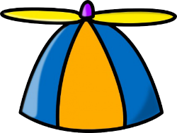
Mon. Feb. 25th – HAT DAY –
Be creative!

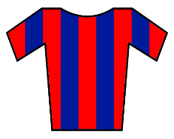
Tues. Feb. 26th – SCHOOL COLORS DAY (red & blue)

Wed. Feb. 27th – PINK SHIRT DAY

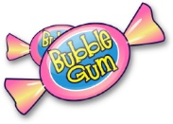
Thurs. Feb. 28th – GUM DAY –
Yes, you can chew gum!

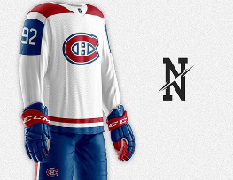
Fri. Mar. 1st – JERSEY DAY OR CRAZY HAIR DAY
Choose your favorite team!

